Assignment Number 1
Fa20-Bcs-151
Aamna Zahid
C Section
Lab: Compiler Construction
Sub. To: Mam Sana Aslam
Question Number 1: Generate first and follows of the following.
E->TE’
E’->+TE’/ε
T->FT’
T’->*FT’/ε
F→(ε)/id
Solution:
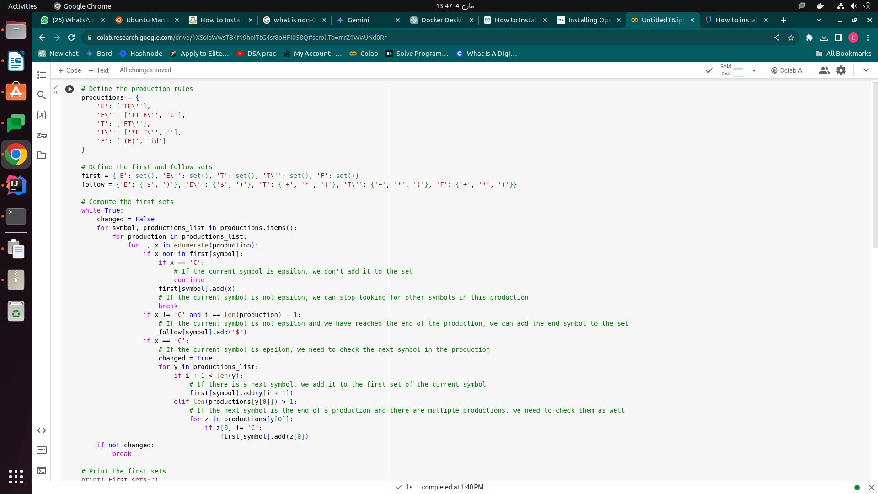Figure 1: Code part a

Output:
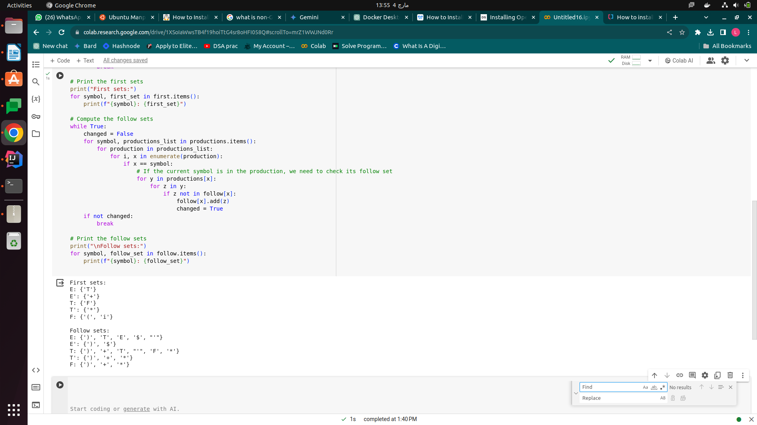Figure 2: Code part b
Figure 3: Output

